**Thoughts and Smiles – Aug. 18, 2025**

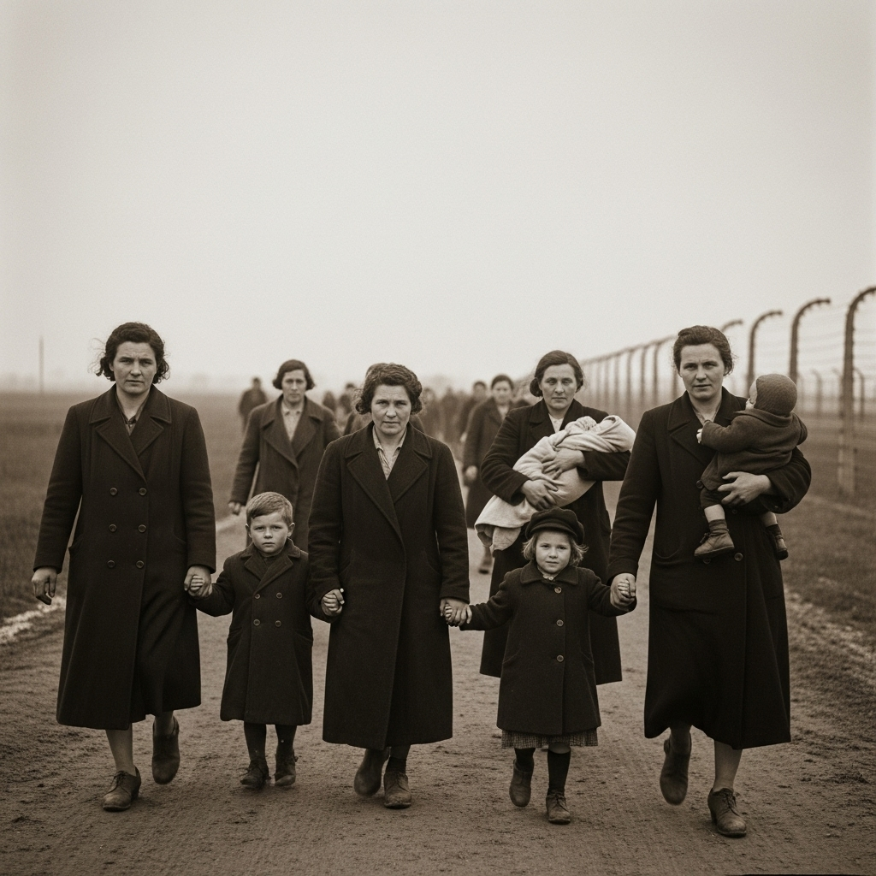The Song They Whispered Before Death — Lublin, Poland, 1942  
  
They did not scream.  
As the mothers were led toward the gas chambers at Majdanek, they held their children close and each other closer. Witnesses recalled the quietest resistance—a lullaby, trembling and soft, sung in Yiddish. A cradle song, once meant to soothe restless babies to sleep, now offered comfort as they walked into smoke and silence.  
  
Their voices were hushed but steady, a chorus of defiant tenderness in the face of unspeakable horror.  
  
One guard, years later, reportedly said:  
“Their song haunted me more than any silence ever could.”  
  
The world did not hear them that day.  
But we can choose to listen now.

***Rozhinkes mit Mandlen* (Raisins and Almonds)**

***If the mothers at Majdanek did indeed sing anything close to this lullaby—perhaps even quietly humming its melody—it would have served not only to soothe their children, but to reclaim their dignity and heritage in the face of horror. A final act of defiant love.***

**Lyrics in Yiddish (partial):**

In dem beys hamikdosh,  
Dort shteyt a klor zeydn bendl.  
Un di mame vet zingen dem kindele  
Rozhinkes mit mandlen.

**Translation (partial):**

In the Temple,  
There hangs a clear silken thread.  
And the mother sings to her little child  
Of raisins and almonds.

**🌟 Why This Song?**

* This lullaby was **ubiquitous** in Jewish households in Eastern Europe before the war.
* It’s tender, hopeful, filled with symbolic nourishment and motherly protection.
* It held meaning not just as a comfort to a child, but as a **cultural memory** of home, love, and hope in the face of exile and uncertainty.
* It would have been passed from mother to child, likely for generations.



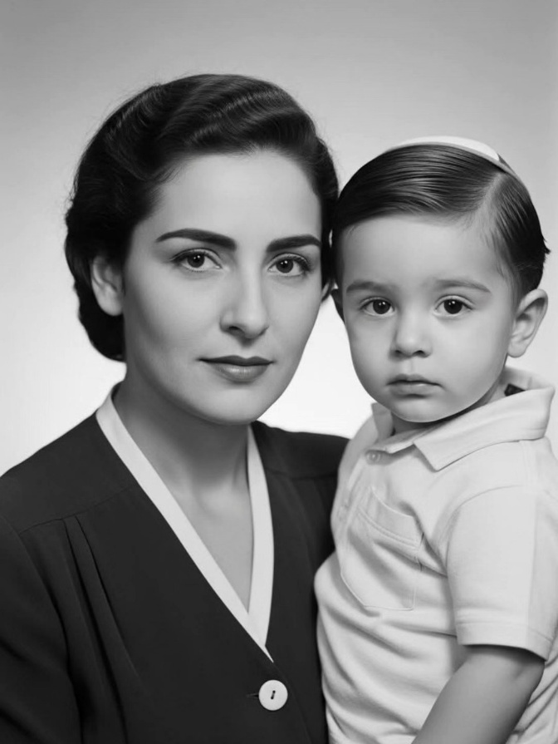A Mother’s Silence  
  
She never screamed her pain.  
She never demanded the world listen.  
She simply survived — and raised a legend.  
  
Flora Klein was a teenage girl when the gates of Auschwitz swallowed her world.  
Her entire family vanished into smoke.  
She emerged alone.  
  
In 1949, standing on the docks of Haifa with nothing but breath and grit, she gave birth to her son — Chaim Witz.  
  
They came to America, not chasing dreams, but fleeing nightmares.  
She worked factory shifts in silence, tucked away her trauma in unmarked drawers, and never once complained.  
  
That boy?  
He became Gene Simmons, the fire-breathing co-founder of KISS.  
  
But Flora never bragged.  
Never asked for applause.  
She bore her history not as a burden, but as armour.  
  
“Everything I am,” Gene said, “is because of my mother.”  
  
When she passed in 2018 at age 93, the world lost a Holocaust survivor.  
But Gene? He lost his North Star.  
  
She wasn’t famous.  
She wasn’t loud.  
But she was unbreakable.  
Auschwitz didn’t silence her. It refined her.  
And in the quiet, she built a legacy that would one day wear face paint and spit fire.  
  
Let the world remember:  
Sometimes the most powerful voices… are the ones that whispered through hell and still chose to sing lullabies.

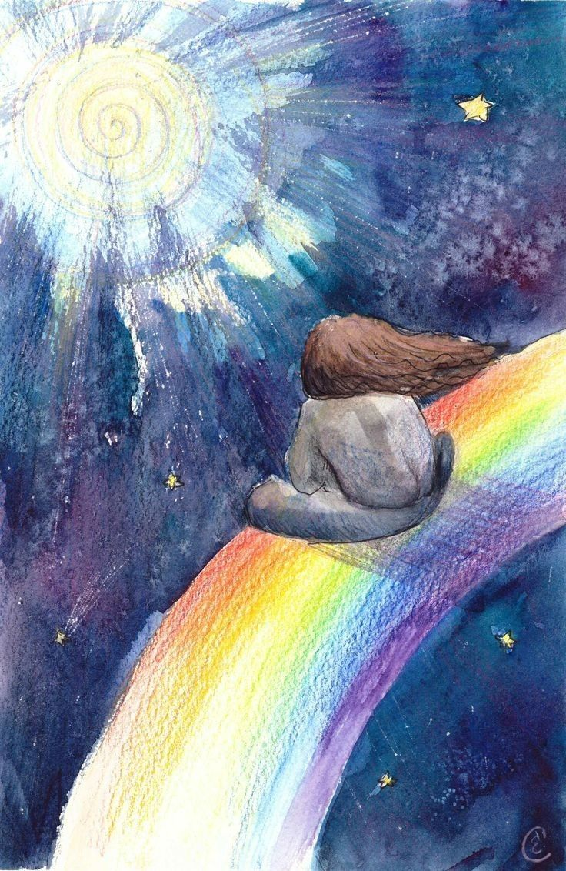

No single day is wasted,  
Although at times it might feel so,  
There are days that seem full and fast,  
Others feel empty and slow.  
  
But each day has a purpose,  
That may not always seem clear,  
Some days we may feel we are being tried,  
And all reasoning disappears.  
  
It's in the quieter moments,  
That the answers come to light,  
So slow down from time to time,  
And dare to give up the fight.  
  
We are given a breathing space,  
For things to settle and realign,  
So be assured when things go quiet,  
It's where the spark of hope can shine.  
  
🖋️ C.E. Coombes

🎨 Katerina Sevostyanova

He asked of me why it was raining  
He asked was it tears from the sky  
And I replied yes  
That this was the case  
That even the heavens can cry  
  
He asked of me what was the thunder  
He said it was hurting his ears  
And I told him that sometimes  
Even the clouds  
Need to scream so that somebody hears  
  
He asked of me what was the wind  
And why was it whirling and swirling around  
So I explained  
Even the sky takes deep breaths  
When it’s trying to calm itself down  
  
Yet often, we keep our tears secret  
And we swallow our own cries for help  
And we think that it’s weak  
To be catching our breath  
So we don’t let our struggles be felt  
  
And yet, if the clouds never emptied  
If the sky never screamed through the storm  
It would sit growing darker  
And darker until  
It was simply no use to us all  
  
So throw all your fears to the wind dear  
And toss all your tears to the clouds  
And you will discover  
The infinite power  
The heavens hold over the ground  
  
See, it’s normal and natural to struggle  
And it’s healthy and human to cry  
And if anyone questions  
Your power my darling  
Just tell them it’s matched by the sky  
  
*****  
  
Becky Hemsley 2022  
Beautiful artwork by Zanya Dahl

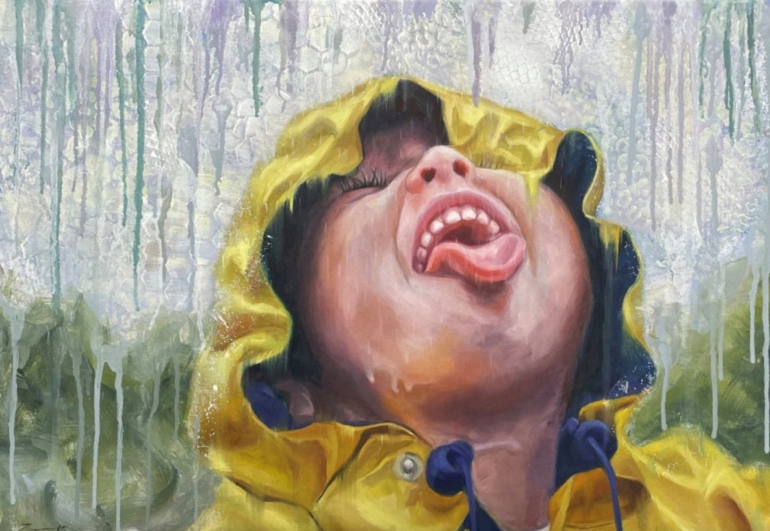

Blessings to you all!

David Jones

Minister

Hepworth-Sauble Beach Pastoral Charge

*Check out "David's Blog" on the Sauble Beach United Church website.*

<https://saubleunitedchurch.ca/category/davids-blog/>

Sometimes, the people you hoped would encourage you won’t. The call you’re waiting for doesn’t come. The comfort doesn’t arrive. And in that quiet place, you’re left with one choice: speak truth to yourself. In this honest and soul-lifting reflection, we return to a vital reminder: when all else falls silent, you can still encourage yourself in the Lord.

<https://youtu.be/j0YrXlUeRsA?si=76Qwe4t2U-ozrqv8>

In THIS emotional and motivational story, we explore the true meaning of life, happiness, and self-worth. Through a symbolic tale, discover how even your imperfections can create beauty and purpose. ✨ Watch till the end — it might change the way you see your own journey.

<https://youtu.be/T5YxURMCHzA?si=t4YM60_jhT3noi8P&t=22>